Practical - 5
Practical Title: Registration Form with Frontend Validation and User-Friendly Error Handling

Problem Definition: Create a student registration form with HTML5 input types and JavaScript validation for name, email, mobile number, password, confirm password, course, year, gender, and terms acceptance. Use Regular Expression for validations.

Theory

Are correct input types and attributes used?
Answer: Yes, suitable input types like text,email and password are used with attributes such as required and placeholder for proper input and validation.

Are validation errors displayed near the relevant fields?
Answer: Yes, validation error messages are displayed close to the corresponding input field, making it easy for the user to identify and correct the mistake.

3. Is password strength checked?
Answer: Yes, password strength is checked using conditions such as minimum length and a combination of uppercase, lowercase, numbers, and special characters.

4. Is the form accessible using keyboard and screen-reader-friendly labels?
Answer: Yes, the form can be navigated using the keyboard and proper <label> elements are associated with input fields to support screen readers.

Implementation

Added input fields for student name, email, mobile number, password and confirm password.

Added course, year and gender selection fields along with the terms and conditions checkbox.

Used suitable HTML5 input types such as text, email and password.

Used JavaScript validation to check whether the entered details are correct.

Used Regex for validating the name, email and mobile number.

Added password strength checking and checked whether the confirm password matches the password.

Displayed validation messages near the fields when incorrect data was entered.

Tested the form with both invalid and valid inputs.

After entering all details correctly and accepting the terms, the form allows successful submission.

Evidence of Work (Screenshots)
Figure 1.1 StudentHub Registration Form
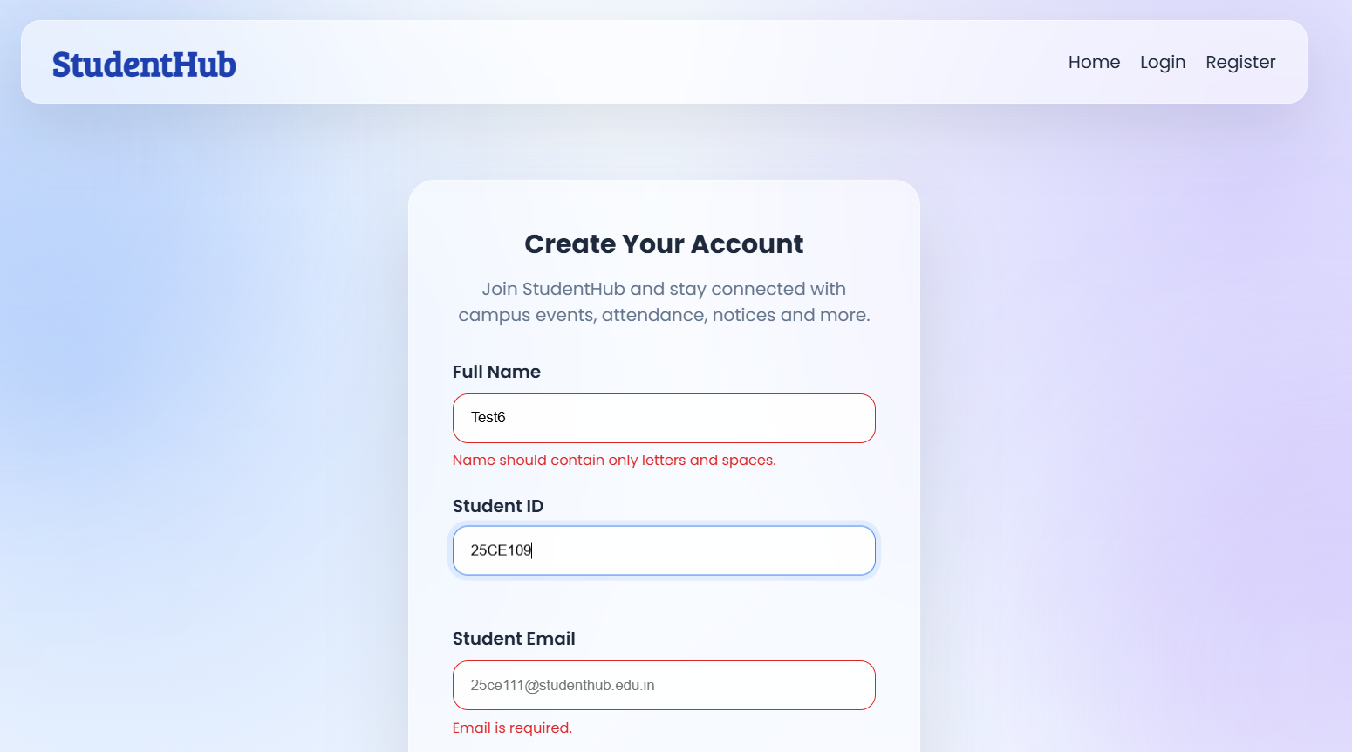
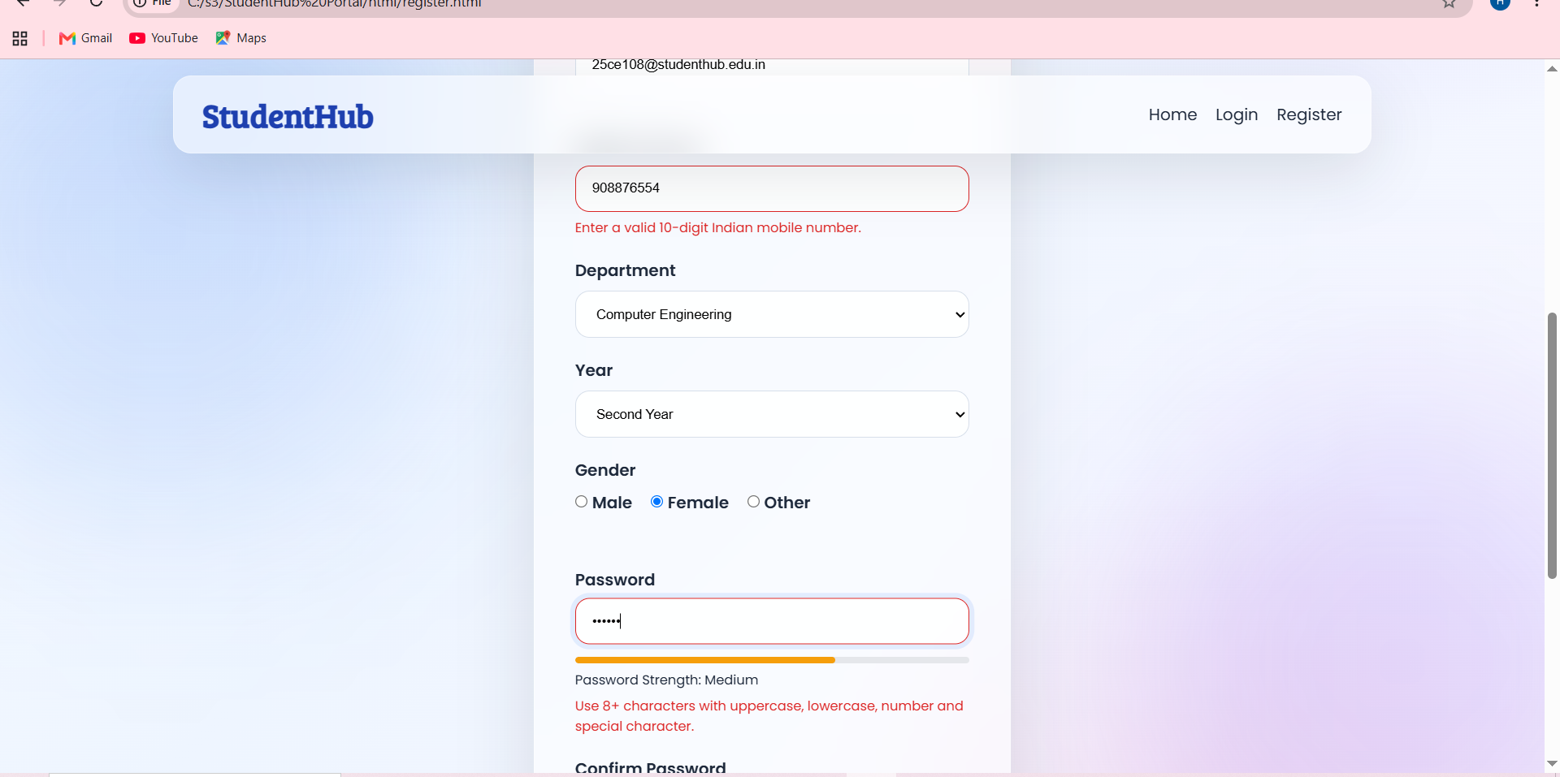
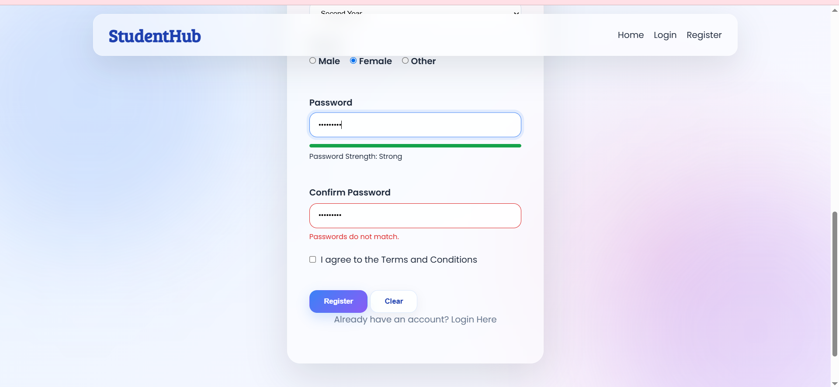
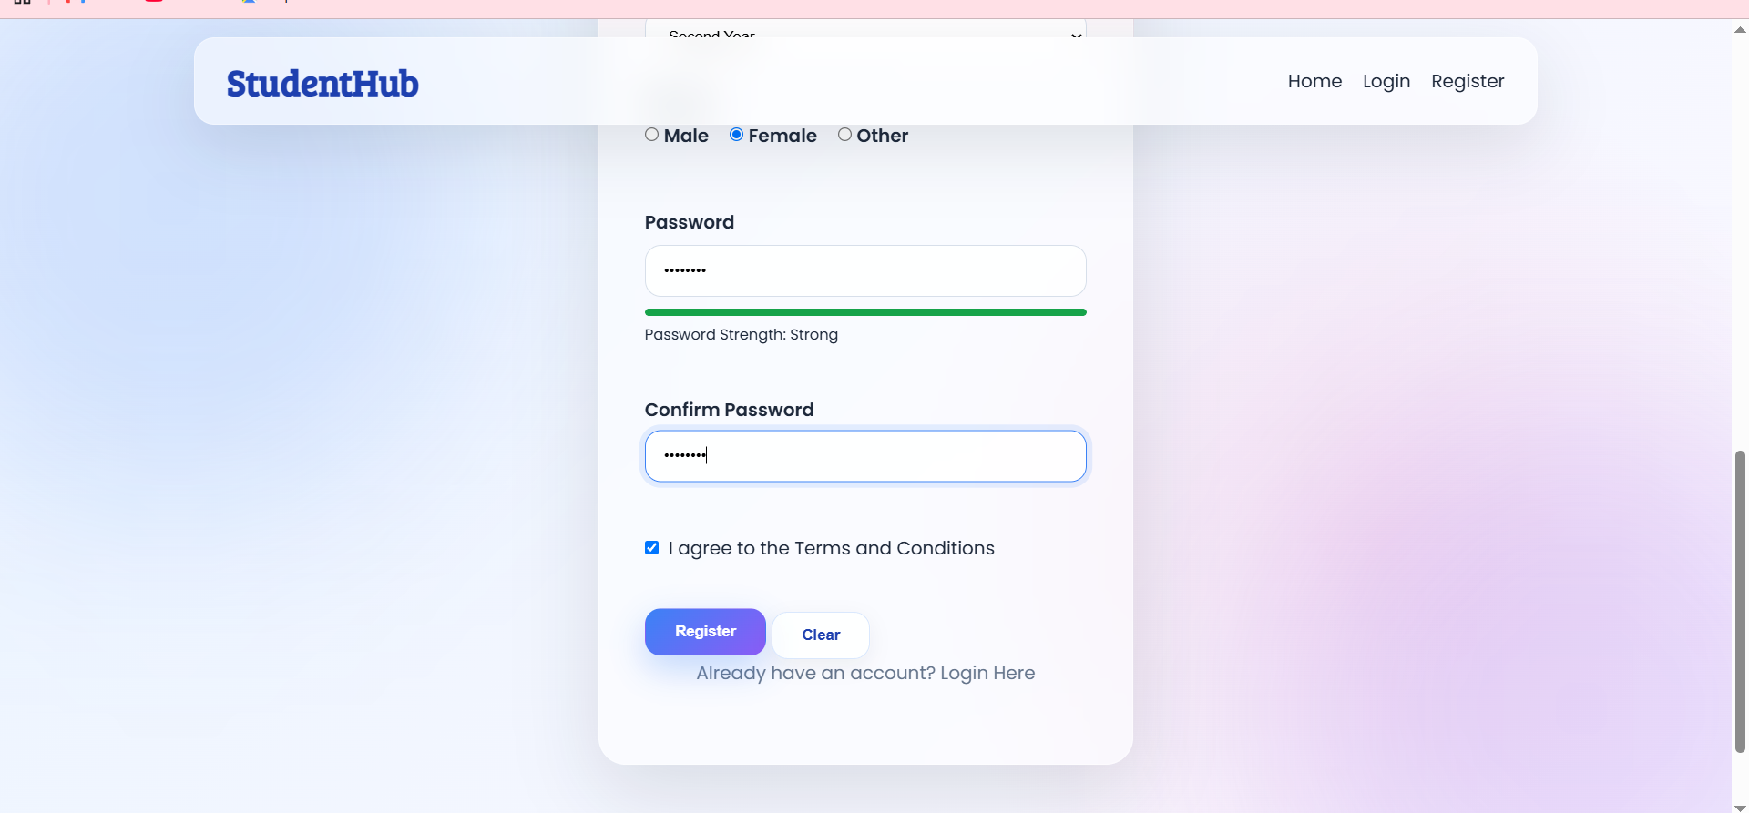
Description : These screenshots represent the registration page . They validate the name,phone number, student id, mail and password strength and password matching.

Figure 1.2 Successful Registration
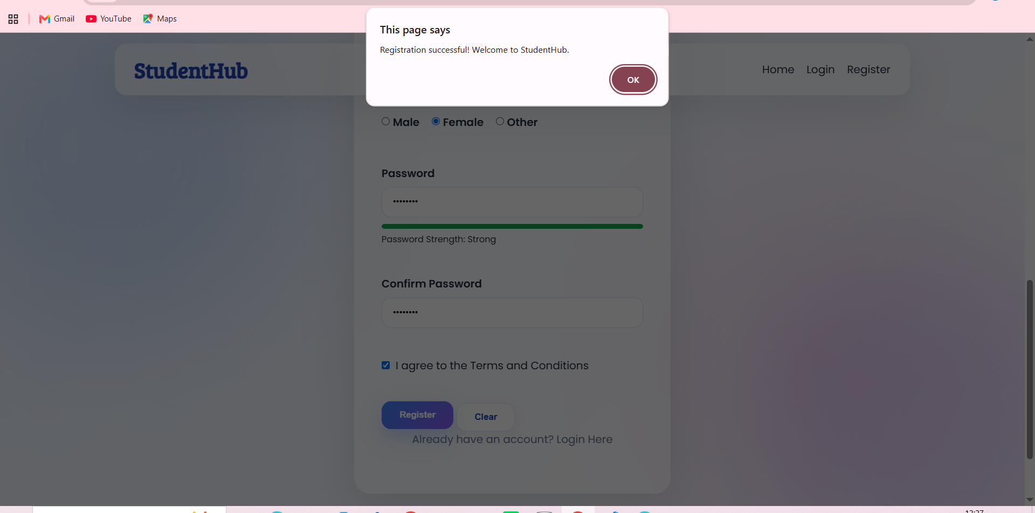
Description: and then if all fields are correctly filled then shows successful registration.

GitHub Repository Link:
https://github.com/heerce27/StudentHub-Portal.git

Challenges Faced:
- I faced some difficulty in applying JavaScript validation correctly to all the registration fields.
- Writing the Regular Expressions for email and mobile number validation took some trial and error.
- I had to fix the condition for the password and confirm password so that both values matched correctly.
- Initially, some validation messages were not appearing at the correct place, so I adjusted the JavaScript and html structure.

Learning Outcomes:

I learned how to use different input types like email, text and password according to the requirement.

I learned how to write and apply Regex in JavaScript for form validation.

I understood how to check password strength and confirm password matching.

I learned how to display error messages based on the user's input instead of only using HTML validation.

Faculty Remarks:

